Processor architecture

practical 2

Division/Batch: A/A3  
Branch: Computer Engineering

|  |  |  |  |  |
| --- | --- | --- | --- | --- |
| **SAP ID** | **Name of Student** | **Date of Experiment** | **Date of Submission** | **Remarks** |
| 60004190054 | Jazib Dawre | 8/10/21 | 8/10/21 |  |

# Aim

To study and implement restoring division algorithm.

# Theory

A division algorithm is an algorithm which, given two integers N and D, computes their quotient and/or remainder, the result of Euclidean division. Division algorithms fall into two main categories: slow division and fast division. Slow division algorithms produce one digit of the final quotient per iteration. Examples of slow division include restoring, non-performing restoring, non-restoring, and SRT division. Fast division methods start with a close approximation to the final quotient and produce twice as many digits of the final quotient on each iteration. Newton–Raphson and Goldschmidt algorithms fall into this category.

Restoring Division Algorithm is used to divide two unsigned integers. This algorithm is used in Computer Organization and Architecture. This algorithm is called restoring because it restores the value of Accumulator(A) after each or some iterations. There is one more type i.e., Non-Restoring Division Algorithm in which value of A is not restored.

Here, register Q contain quotient and register A contain remainder. Here, n-bit dividend is loaded in Q and divisor is loaded in M. Value of Register is initially kept 0 and this is the register whose value is restored during iteration due to which it is named Restoring.

# Algorithm

Restoring division operates on fixed-point fractional numbers and depends on the assumption 0 < D < N. The basic algorithm for binary (radix 2) restoring division is:

R := N

D := D << n *-- R and D need twice the word width of N and Q*

**for** i := n − 1 .. 0 **do** *-- For example 31..0 for 32 bits*

R := 2 * R − D *-- Trial subtraction from shifted value*

**if** R ≥ 0 **then**

q(i) := 1 *-- Result-bit 1*

**else**

q(i) := 0 *-- Result-bit 0*

R := R + D *-- New partial remainder is (restored) shifted value*

**end**

**end**

In simpler terms, let the dividend be Q and the divisor be M and the accumulator A = 0.

Therefore:

1. At each step, left shift the dividend by 1 position.
2. Subtract the divisor from A (A – M).
3. If the result is positive, then the step is said to be successful. In this case, the quotient bit will be “1” and the restoration is not required.
4. If the result is negative, then the step is said to be unsuccessful. In this case, the quotient bit will be “0” and restoration is required.
5. Repeat the above steps for all the bits of the dividend.

# Example

**Problem: 13/4 M=0100 Q=1101 -M=1100 N=4**

|  |  |  |  |  |
| --- | --- | --- | --- | --- |
| **N** | **M** | **A** | **Q** | **Operation** |
| 4 | 0100 | 0000 | 1101 | Initialization |
|  | 0100 | 0001 | 101- | LS, N=N-1 |
|  | 0100 | 1101 | 101- | A=A-B |
|  | 0100 | 0001 | 1010 | A=A+B |
| 3 | 0100 | 0001 | 1010 |  |
|  | 0100 | 0011 | 010- | LS, N=N-1 |
|  | 0100 | 1111 | 010- | A=A-B |
|  | 0100 | 0011 | 0100 | A=A+B |
| 2 | 0100 | 0011 | 0100 |  |
|  | 0100 | 0110 | 100- | LS, N=N-1 |
|  | 0100 | 0010 | 100- | A=A-B |
|  | 0100 | 0010 | 1001 |  |
| 1 | 0100 | 0010 | 1001 |  |
|  | 0100 | 0101 | 001- | LS, N=N-1 |
|  | 0100 | 0001 | 001- | A=A-B |
|  | 0100 | 0001 | 0011 | Termination |

**Result: Quotient: 0011 Remainder: 0001**

# Flowchart

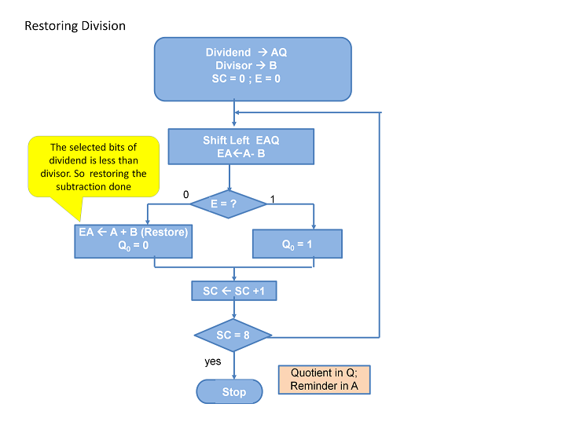

# Code

#include <iostream>

#include <string>

**void** decimal_to_binary(**int** n, std::string**&** bin_num) {

    if (n / 2 != 0) {

        decimal_to_binary(n / 2, bin_num);

    }

    bin_num.append(std::to_string(n % 2));

}

**void** format_decimal_to_binary(**int** n, std::string**&** bin_num) {

    decimal_to_binary(n, bin_num);

    while (bin_num.length() != 4) {

        bin_num.insert(0, "0");

    }

}

**void** add_binary(std::string**&** bin_num1, std::string**&** bin_num2) {

    std::string resp;

    std::string carry = "0";

    for (**int** i = bin_num1.length() - 1; i >= 0; i--) {

**int** ones = 0;

        if (bin_num1[i] == '1') {

            ones++;

        }

        if (bin_num2[i] == '1') {

            ones++;

        }

        if (carry == "1") {

            ones++;

        }

        if (ones == 3) {

            resp.insert(0, "1");

            carry = "1";

        } else if (ones == 2) {

            resp.insert(0, "0");

            carry = "1";

        } else if (ones == 1) {

            resp.insert(0, "1");

            carry = "0";

        } else {

            resp.insert(0, "0");

            carry = "0";

        }

    }

    bin_num1 = resp;

}

**void** ones_complement(std::string**&** bin_num) {

    std::string resp;

    for (**char**& c : bin_num) {

        resp.append(c == '1' ? "0" : "1");

    }

    bin_num = resp;

}

**void** twos_complement(std::string**&** bin_num) {

    std::string resp;

    std::string one = "0001";

    ones_complement(bin_num);

    add_binary(bin_num, one);

}

**void** subtract_M(std::string**&** Q, std::string**&** A, std::string M) {

    std::string _M = M;

    twos_complement(_M);

    add_binary(A, _M);

}

**void** left_shift(std::string**&** Q, std::string**&** A) {

    A.erase(A.begin());

    A.push_back(Q.front());

    Q.erase(Q.begin());

    Q.append("_");

}

**void** check_result(std::string**&** Q, std::string**&** A, std::string**&** A_back) {

    Q.pop_back();

    if (A[0] == '0') {

        Q.append("1");

        A_back = A;

    } else {

        Q.append("0");

        A = A_back;

    }

}

**void** print_result(std::string**&** Q, std::string**&** A) {

    std::cout << "\nQuotient:  " << Q << "\nRemainder: " << A << std::endl;

}

**int** main() {

    std::string Q, M, A, A_back;

**int** q, m;

    std::cout << "\nEnter Dividend: ";

    std::cin >> q;

    std::cout << "Enter Divisor:  ";

    std::cin >> m;

    format_decimal_to_binary(q, Q);

    format_decimal_to_binary(m, M);

    A = "0000";

    std::cout << "\n n"

              << "\t"

              << " M"

              << "\t"

              << " A"

              << "\t"

              << " Q" << std::endl;

    for (**int** i = Q.length() - 1; i >= 0; i--) {

        std::cout << "\n " << i + 1 << "\t" << M << "\t" << A << "\t" << Q << std::endl;

        left_shift(Q, A);

        std::cout << "\t" << M << "\t" << A << "\t" << Q << std::endl;

        A_back = A;

        subtract_M(Q, A, M);

        std::cout << "\t" << M << "\t" << A << "\t" << Q << std::endl;

        check_result(Q, A, A_back);

        std::cout << "\t" << M << "\t" << A << "\t" << Q << std::endl;

    }

    print_result(Q, A);

    return 0;

}

# Output

1. **13 / 4** 2. **7 / 2**

1. **9 / 4**

# Conclusion

The restorative division algorithm is an efficient way to perform binary division compared to traditional subtractive based algorithms by using the faster processed bit shift commands in the CPU registers. The algorithm is simple enough to be implemented in hardware in equipment like Arithmometers while also generalising to complex modern day systems. The algorithm serves as a good example in showing that considering lower-level system dependencies and physical limitations can be used to optimize algorithms.